

**Job Vacancy**

Job Role: Veterinary Surgeon

We are looking for a friendly, team focused individual with, ideally, 2-5 years previous experience. This is a genuine opportunity for a colleague to develop their career and hone their particular interest’s whether they be clinically focused, mentoring and teaching junior colleagues or supporting business development. This is a predominantly small animal role in a proudly independent, mixed practice. There is potential to participate in equine work which would be an advantage.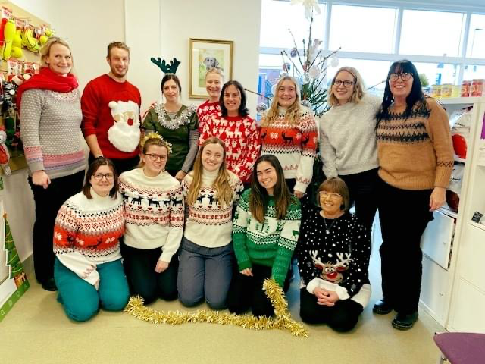

Beautiful mid Devon near Exeter, moors and coasts and a 4-day week, so lots of scope to develop a great work/life balance.

We have purpose built, small animal facilities which we are continually striving to improve, with current ongoing work to extend our prep and kennel area. We boast laparoscopic capabilities, full range of endoscopes, dental radiography, ultrasound and intention to upgrade our radiography to DR in the near future. We have an onsite rehabilitation team with underwater treadmill and laser. Visiting orthopaedics and ophthalmology services.

Equine hospitalisation facilities on site are currently under construction.

We are an approachable team, experienced in providing an environment for colleagues to thrive. We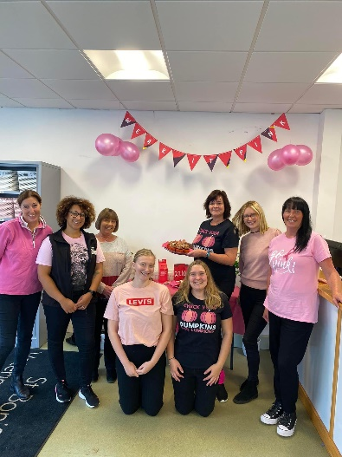 are proud to cover our own out of hours Rota which ensures our clients and their pets have continuity of care. It ensures our vets and nurses develop key skills in managing emergency cases and can follow them though to outcome. There is always someone who is happy to provide support or advice if required. We appreciate the need to balance night work with time off, so we have developed a block week on call arrangement with time off during the day. We are constantly honing this to give the best work/life balance for the team. Our dedicated, on-site night nurses take care of your inpatients so you can be confident of providing a first-rate level of care.

15-minute appointments are standard with emphasis on building strong client relationships.

We are active members of the XLVets community which provides a further support network of colleagues, young and old for advice, guidance and general camaraderie! You would be encouraged to participate in the XLVets CPD Programme where you will meet contemporaries from similar practices. Courses might include mentoring, leadership, difficult conversations, or clinically focused topics which we can champion within the network. You would be encouraged and funded to work towards a certificate if a more clinical focus was desirable.

* 4-day week,
* 1 in 6 rota (lovely on-site accommodation for on call duties if desired.)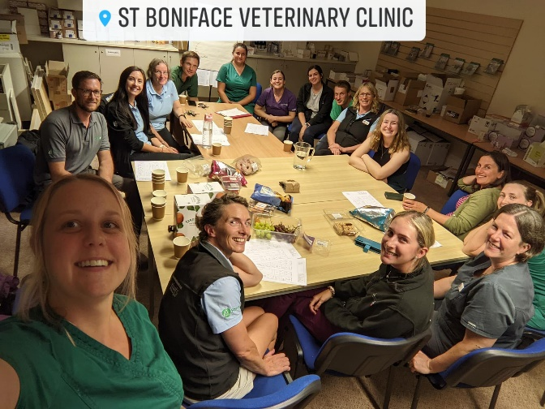
* On site night nursing support
* Block week of on call/time off during the day
* RCVS and VDS paid
* Generous CPD allowance
* Pension scheme
* Staff discounts
* Employee assistance programme

Apply with CV to [marie@stbonifacevets.co.uk](mailto:marie@stbonifacevets.co.uk)